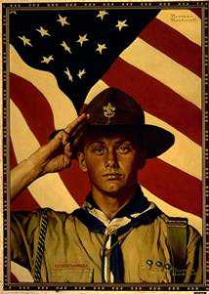
BSA Troop 837 Car Wash Fundraiser
Sponsored by:
Lee & Cates Glass
And
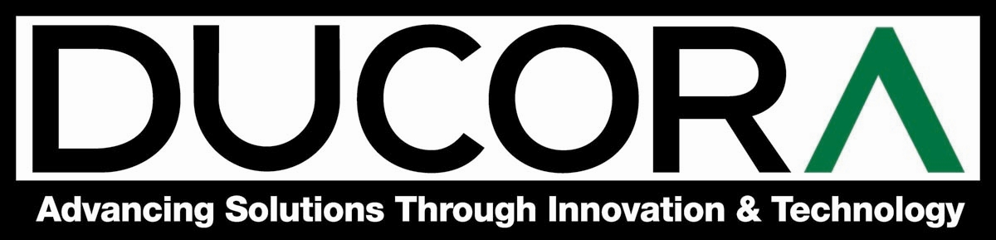
When: Saturday May 23rd
Time: 10 am to 3 pm
Place: 130 N. 3rd St.
Jacksonville Beach

COME & JOIN THE FUN WHILE SUPPORTING YOUR LOCAL
BOY SCOUTS OF AMERICA TROOP NO. 837


